# Notes

**Some graphs per year, comparing H1N1 and “other flu-like symptoms”**

* For “other flu-like symptoms”, all cases, by generation:

* By age:

* There seems to be a clear generational effect, that is somewhat intermingled with an age effect (see how, as we move from 2009 to 2019, the lowest susceptibility point is pushed to the right, from age 9-10 to age 15-16)
* Same thing for H1N1, for which the cohort effect is perhaps even stronger
* By generation:

* By age:

* Although there are clear differences between the two tendencies (e.g., flatter increased of susceptibility with age for H1), it is clear that the category “other” flu-like symptoms, without positive test for influenza has “retained” some of the characteristics of H1N1 (e.g., the hump at younger ages), particularly at the time of the pandemic, meaning that quite a few tests might have been falsely declared negative
* Keeping only 2009-2010, we have:

* The curve for “other” is having a hump at g1984, and doesn’t increase sufficiently fast with age
* Comparing with 2018-19, we see rates :

* Looking now at deceased individuals, and for other flu-like symptoms:

* It is clear that many positives were missed for the 1984 generation in 2010 as well, for example…
* Note also how the lowest susceptibility doesn’t align well with the generation, but rather with age:
* The minimum susceptibility is around age 10
* This is somewhat different for H1N1, for which g2003 seems to keep its lowest susceptibility status for mortality, at different ages (why?). By generation:

* By age, the picture is much less clear:

**Evidence for antigenic sin within the H1N1 subtype recurrent infections**

* Looking at more recent years, we can also see evidence of imprinting, even in more recent generations, and *within the same subtype*
* From 2016-2019, the generation 2009 has a high ratio h1/(other+b+h3) for all cases (survivors and deaths) relative to the surrounding generations
* Note: I use a linear (not logged) scale on the y-axis here because there are too many zero-values

:

* This is perhaps not the result of increased susceptibility per se, but rather due to a lack of reduced susceptibility normally seen at younger ages (captured in the “other” curve, but not in the H1N1 curve)
* Children from the 2009 generation are aged 7 to 10 in this graph, i.e., when overall susceptibility to pulmonary diseases decreases sharply to its minimum (around age 10, see below)
* With a different scale on the Y-axis:

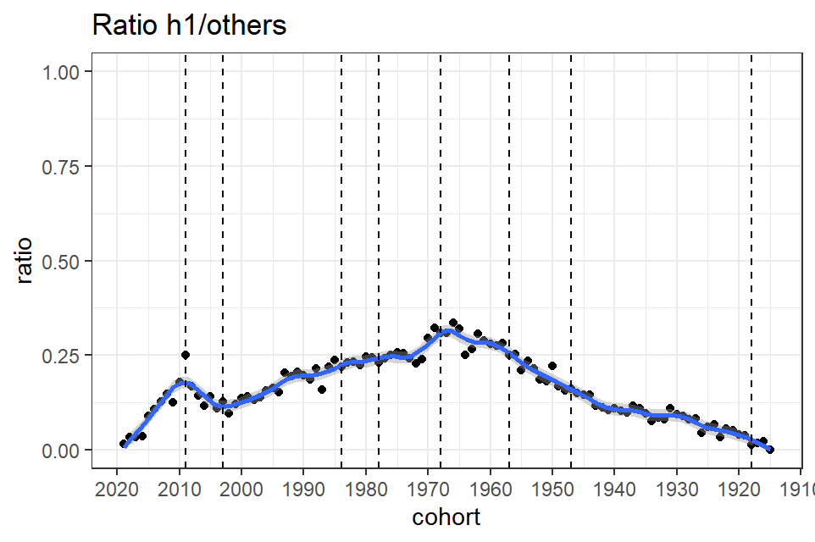

* Such increased ratio relative to surrounding generations could also be expected during the pandemic at very young ages, not because of imprinting (which is in fact not yet “effective”, but more simply because very young individuals are usually highly susceptible to influenza
* Exactly the opposite is true.
* This is for the year 2009-13:

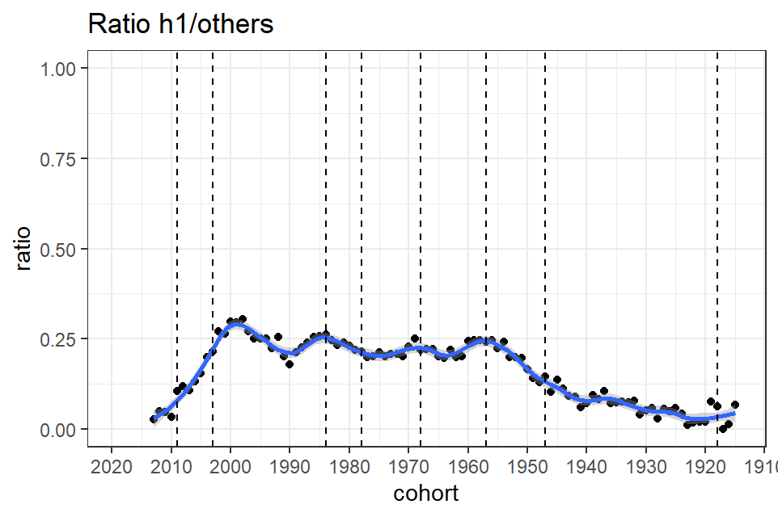

* As can readily be seen, there are *no increase of susceptibility in the generation 2009* during the pandemic years (2009-2013), when these individuals are newborn or babies
* This indicates that very young children are clearly spared during the pandemic
* Relative to other seasonal influenza viruses or other viruses leading to flu-like symptoms, babies or newborn are less likely to be infected to pandemic influenza, or require hospitalisation (the same phenomenon was obvious during the covid outbreak; very young individuals, babies, were apparently completely spared)
* The increased susceptibility seen for g2000 is perhaps an age effect; 9-12 years are pretty much the age with the lowest susceptibility for most diseases, including infectious airborne diseases; high ratios are easy to create at this age because of the very small denominator (it’s not that the rate of H1N1 cases is higher at slightly younger or older ages)
* In other words, for any pandemic that will elevate susceptibility at young ages (which is what influenza pandemic do) will create a high ratio pandemic/other disease at ages 9-12 years
* (show this by putting age on the x-axis for a few successive years)
* Now looking at **deaths,** instead of all cases:
* 2016-2019, death rate ratios (drr):

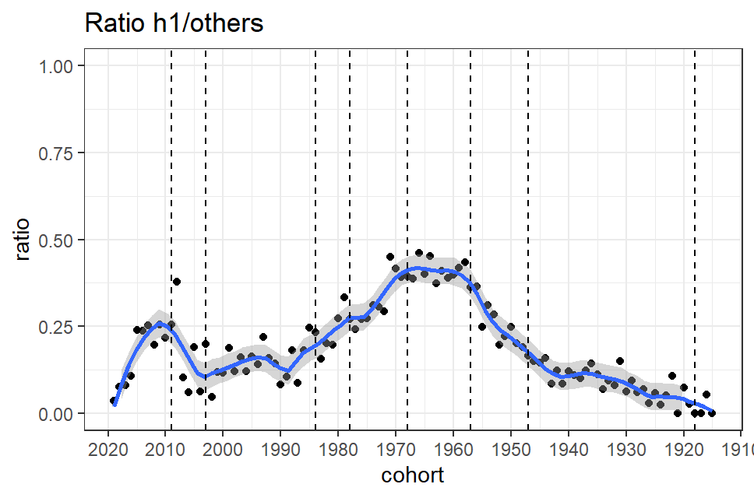

* The peak on the smoothed curve is not exactly for the 2009 generation – it is rather for the 2010 generation – but the highest point is for 2008, meaning the 2009 is still a strong candidate
* Note also how in general ratios are larger for the imprinted cohorts (*careful however that this could be because there are perhaps less false flu-negative for the deceased, making the ratio higher for them*), e.g. 1957 and 1968, although there is no clear separation between the two
* This separation was nevertheless obvious a few years earlier, i.e., between 2009 and 2013, as well as the signal for the g1984, but again, the imprint for the g2009 can’t bee seen:

2009-13, drr:

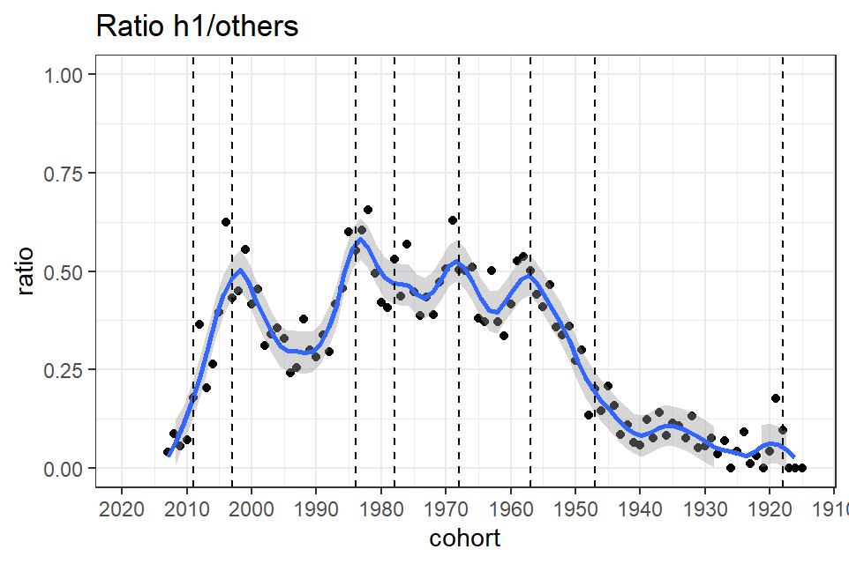

* This is very strong evidence that during the pandemic and resurgent outbreaks that immediately followed, imprinting affected those born during pandemics (1957, 1968) or significant shifts (1933, 1984); again, as stated above with regards to all cases of H1N1, the peak around 2000 is most likely an age effect
* Or is it?====

**Vaccination**

* The above ratios can be computed by *vaccination statuses*, for all cases or the deceased
* Here, we can’t look at the 2009 pandemic because vaccine were not ready
* We also have to wait a few years if we are interested in finding an imprint for the same reasons presented above – and I would add that an imprint cannot be detected while it is put on (it will be revealed a few years later)
* For the vaccinated, from 2014-2019, the following depicts the ratio of deaths from H1 versus other ILI:

* For the *non-vaccinated* and for the same years (2014-19):

* The imprint is seen for both vaccinated and not-vaccinated in the g2009, but not for the g1947, and it is not clear for the g1968
* Also, the hump is a much less obvious for the g1933
* Among all cases, and the vaccinated:

* Not vaccinated:

* Les ratios pour les cohortes « centrales » sont bien plus élevés chez les vaccinés, ce qui démontrerait une efficacité notable de la vaccination (par exemple, pour la g1968, le ratio est de 0,35 environ chez les non-vaccinés et d’environ 0,17 chez les vaccinés, donc le risque semble divisé par deux)
* Les empreintes antigéniques demeurent visibles dans les deux cas
* Par exemple, on voit bien l’empreinte associée à la g2009 à la fois chez les vaccinés et les non-vaccinés, même si le ratio est plus élevé dans le dernier cas
* Seule l’empreinte de 1957 apparaît effacée chez les vaccinés (mais la distinction entre 1957 et 1968 s’efface dans les années récentes)

**Case fatality rate ratios**

* We can also look at the implications of vaccination for CFRR (case fatality rate ratios) by comparing, in vaccinated versus not-vaccinated individuals (or unknown statuses), CFRs of H1N1 to CFRs from all other influenza-like symptoms (positive for H3N2, B or not positive for any influenza virus, i.e., sub=other)
* The rationale behind the idea of using all flu-like symptoms but H1N1 is that it provides an age-adjusted comparison group for susceptibility to diseases provoking influenza-like symptoms
* Thus, generational or cohort effects are expected to surface over and above an age adjusted background of similar susceptibility
* If someone has co-morbidities that are related to his age, or even to his cohort, defined in broader terms than single-year cohorts (e.g., baby boomers), there would be no reason for that comorbidity to surface even more if that person was born during a pandemic or antigenic drift
* The fact that there is a peak at 1968 would be a clear indication of the role of antigenic imprinting
* We have to start after 2009 because there was no vaccination during the pandemic (but a massive campaign in 2010)
* For convenience, I begin in 2012 (and up to 2019) with individuals not vaccinated or without vaccine status:

* There is nothing particularly noticeable for the g2009
* But there are some clear signals of susceptibility for those born between 1957 and 1968 (this in fact even starts with increased numbers of cases for these generations, and the increased CFRR is on top of this higher susceptibility to be sick to begin with)
* Now looking at vaccinated cases (vaccine==1) for the same years:

* The signal for the g2009 seen above is reappearing, although not very strongly, and the youngest individuals born recently are at the highest risk of fatality this time (relative to risks associated with other viruses or conditions with flu-like-symptoms)
* For the other generations, it seems that the antigenic imprinting has been “removed,” with apparently not significant deviations from a cffr=1 (although the confidence intervals are loosely evaluated with the smoothing method, i.e., lowess and are rather conservative)
* In fact, if anything, those born during antigenic shifts or pandemics appears spared if vaccinated (especially those born around 1978 or 1984, and both c1968 and c1957 have a low cffr)

**The 1933 generation (year with an important antigenic drift)**

* Looking at years 2009-2019, *without distinction in vaccination status*:

* The peak are not very prominent, but there are some signals (at least second-order) around g1984, g1968, g1957, and especially g1933
* Splitting the period in two, with 2009-2013 first:

* And 2014-2019:

* We see that the c1933 signal is consistent over time (at least the second-order, i.e., second derivative is is significant)
* Also, signal for young generations (e.g., 1984) have almost completely vanished

# Questions

# Vaccination

# What are the vaccination dates in 2009?

# Most likely long after the pandemic

# Massive campaign in 2010

# There are a lot of missing information on the date of vaccination, and thus we don’t know if the person said to be vaccinated from the flu was vaccinated recently, the year before, or a few years ago? Or was it once, twice, etc.? Can we have more information on this?

# There seems to be many missing b influenza cases, and perhaps h3

# In the paper, ===, proportion of subtypes are listed by years:



|  |  |  |  |  |
| --- | --- | --- | --- | --- |
| **Year** | **A/H1N1** | **A/H3N2** | **B Victoria** | **B Yamagata** |
| **2010** | 41.1% | 12.9% | 2.3% | 43.7% |
| **2011** | 19.7% | 46.1% | 34.2% | 0% |
| **2012** | 41.9% | 39.7% | 0.987% | 17.4% |
| **2013** | 39.5% | 21.6% | 36.6% | 2.23% |
| **2014** | 11.6% | 65.1% | 1.95% | 21.4% |
| **2015** | 8.39% | 55.0% | 3.81% | 32.8% |
| **2016** | 65.2% | 2.71% | 26.2% | 5.90% |
| **2017** | 0.6% | 60.9% | 6.63% | 31.9% |

Table S1: Proportions of influenza A/H1N1, A/H3N2, B Victoria, B Yamagata circulating for the period 2010-2017 in Brazil.



Si on répartit les « an » pour moitié chez les H1 et l’autre chez les H3, ça tue encore plus les b :

# What to do with cases with no confirmed influenza

# Vastly more numerous than those with confirmed PCR (includes all ILI cases; apparently collected with the surveillance system)

# Very numerous in 2009, suggesting that most are influenza infections to H1N1; yet, the pattern of increased susceptibility for the 1957 is poorly reproduced among these “other”:

# And yet, rate is not so high for the 1957 generation, with ILI, but not positive influenza test:

Avec les autres qui n’ont pas de tests positifs d’influenza (other) :

